Grade 6 Equations/algebra practice

Part A: Multiple Choice Circle the letter of the best answer to each question.
- Look at the pattern below. How many squares will there be in figure 5?

Figure 1 Figure 2 Figure 3 Figure 4

- 10 B. 12 C. 14 D. 16

2. How many squares will be in figure 6?
Figure 1 2 3 4

- 11 B. 12 C. 13 D. 15

3. What is the missing value?
A. 9
B. 10
C. 11
D. 12
4. Match the following table of values to the correct equation.
Term Number (N) | 1 | 2 | 3 | 4
Pattern (P) | 4 | 7 | 10 | 13

- 2n + 2= P B. 2n + 3= P C. 3n + 1= P D. 3n + 2= P

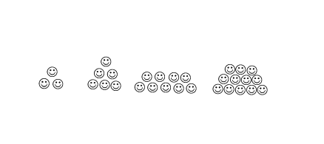
5. Which expression represents the picture below?

Term 1 2 3 4

Note: “N” represents the term number

- 2n B. 2n + 1 C. 3n D. 3n + 1
Number | Term Value
1 | 4
2 | 6
3 | 8
4
5 | 12
6 | 14

6. Which table below matches the algebraic expression: 2T + 5

( a) ( b) ( c)

Term  Number | Number of Dots
1 | 0
2 | 3
3 | 6
4 | 9
5 | 12
Term  Number | Number of Dots
1 | 6
2 | 11
3 | 16
4 | 21
5 | 26
Term  Number | Number of Dots
1 | 7
2 | 9
3 | 11
4 | 13
5 | 15

- What is the value of “$n$”? $9=\frac{n}{3}$

- 12 b) 3 c) 27 d) 6

- What is the value of “$x$”? $3x = 90$

- 30 b) 270 c) 87 d) 93

- What is the value of “$n$”? $2n – 6 = 14$

- 5 b) 13 c) 10 d) 4

- What is the value of “$x$”? $11=\frac{x}{5} +2$

- 57 b) 45 c) 14 d) 9

Part B: Constructed Response -Answer all questions in the space provided. Show all necessary work for full credit.

- Find the value of $"n"$ in the following one step equations
You must show all your steps.

- $n – 9 = 6$ c) $6 + n = 17$

- $4n = 36$ d) $\frac{n}{3}=7$

- Solve the following two step equations. You must show all steps and show how you would check the accuracy of your answer.
Equation (2 marks each) Verifiy/Check answer (1 mark each)

- $3m – 7 = 14$
- $4d+15 = 35$
- $\frac{n}{2}- 4=7$

- $8=\frac{n}{6}+ 4$

- Match each pattern with the algebraic expression that represents the number of squares in the n^{th} term.

Note: “N” represents the term number

Pattern Expression

a) i) 4n

b) ii) 3n + 1

c) iii) 2n + 1

d) iv) 2n - 1

Part C: Applications & Problem Solving - Read the questions carefully and use the mark value to guide the depth of your responses. Answer each question in the space provided.

D-1: Students will be able to continue and explain a pattern as a relation.
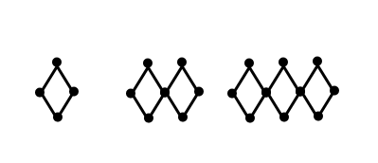
1. Given the following pattern:

Term 1 Term 2 Term 3 Term 4 Term 5

a) Draw the 4th and 5th terms in the space above.

b) Complete the table of values.
Term  Number  (T) | Number of  Dots  (D)
1 | 4

c) Describe the pattern in words.

d) Write an algebraic equation for the pattern.

e) Create a graph for the pattern from your table of values.
Please label all axes properly.

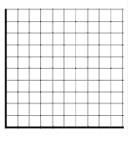

- Predict the number of dots in the 15th term.
Explain or show how you know!

g) Which term will have 151 dots? Explain how you know!

2. From the relation: y = 2x + 1, create a table of values for 5 terms and graph it.

X | Y

