Let’s Make a Parachute and Test Air Resistance Experiments
Materials:
- plastic grocery bag
- dinner plate
- yarn or string
- tape
- scissors
- hole punch
- marker
- heavy object to act as our “parachuter”
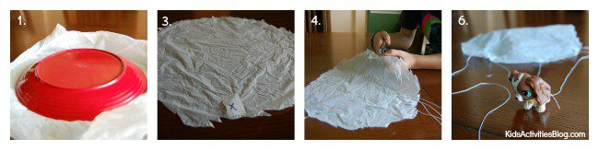Instructions:
- Using the plate, trace a large circle on one side of the plastic bag and cut it out
- Mark four spots around the circle with a marker, equal distance apart
- Cover each spot with a piece of tape to make the area less resistant to tear
- Punch a hole out of each spot
- Take 4 pieces of the same length of yarn and attach one to each of the holes
- Tie the 4 pieces of yarn to the parachuter
- Find a place to drop your parachute that will give you some height – top of the staircase, off the top of a jungle gym, etc.

Play Parachute
Remember, you want the parachute to drop slowly to the ground. Drop a “parachuter” of similar weight without the parachute off the same place and see what happens. Why do you think the parachute makes it drop slowly?
