Parachutes: Does Size Matter?

Experimental Procedure
- Each parachute will be made out of the garbage bag material, so first cut open the garbage bags to make a flat sheet of plastic.
- You will make a series of four parachutes of different sizes, from large to small. Each parachute will be square in shape, so the four sides will each be of the same length. Table 1 below shows the list of parachute sizes you will try.
Parachute | Length of Each Side (cm) | Surface Area (cm²)
1 | 20 | 400
2 | 30 | 900
3 | 40 | 1600
4 | 50 | 2500
Table 1. In this science project you will try a variety of different sized parachutes. This table shows the different sizes you will try, with the sizes given in centimeters (cm).
- Cut out each of the four differently sized parachutes from the garbage bag material.
  - Tip: One trick is to fold the plastic sheet in half twice so that it is four layers thick. Then cut the two edges (opposite the folded sides) down to half of the length you want your square to be. When you unfold it, you will have your square!
- For each parachute, tie a knot in each of its four corners.
  - The knots will be used to anchor your string.
- Cut 16 pieces of string, making each be 40 cm long.
  - Each parachute will need four pieces of string.
- For each parachute, tie one end of each piece of string around one of the four knots, positioning the string right above the knot, as shown in Figure 2 below.
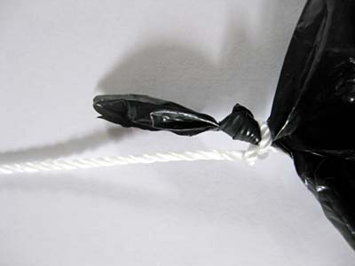
Figure 2. For each parachute, tie a piece of string just above each knot.
- For each parachute, hold the center of the plastic sheet in one hand and pull all strings with the other to collect them. Tie the free end of the strings together with an overhand knot, as shown in Figure 3 below.
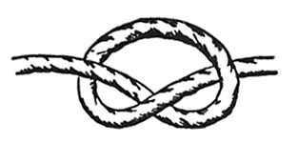
Figure 3. For each parachute, tie the ends of the strings together using an overhand knot, as shown here.
- Attach 1 washer to each bundle of strings with a twist tie. Alternatively, if you are using pennies and tape instead, tape 2 pennies to each bundle of string.
  - Be sure that each parachute has the same number of washers or pennies attached, or this will alter your results!
  - Your parachutes should now look like one of the parachutes in Figure 4 below.
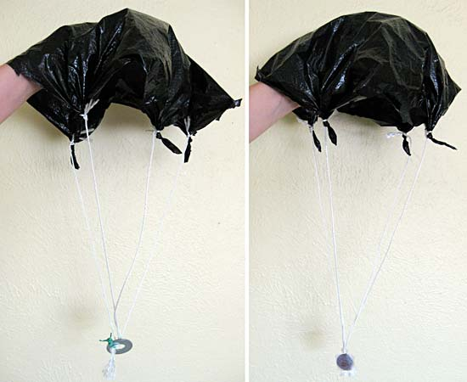
Figure 4. Your completed parachutes should look like one on the left if you used a washer and twist tie or the one on the right if you used pennies and tape.
- In your lab notebook, make a data table that looks like Table 2 below.
  - You will be recording your results in this data table.
- Bring a stopwatch, the parachutes, and your lab notebook to a safe, high surface for your tests, about 2 meters from the ground.
  - A good place for your test might be a secure balcony, deck or playground platform.
- Using your stopwatch, time how long it takes in seconds for each parachute to fall to the ground. Be sure to release the parachute from the same height each time. You may want to have a helper help time the parachutes when you release them.
  - If the parachute does not open during a trial, just do that trial over so that when you are finished you have three trials which all worked.
  - Test each parachute three times. Each time record your results in the data table in your lab notebook.
  - Make an average of your data. Calculate the average by adding together your three times, and then dividing your answer by three. Record the averages in your data table.
  - You can also increase the number of trials above three to get better data and organize your data table accordingly.
  - Tip: If the parachutes seem to be falling too fast, you could try using a smaller washer of fewer pennies for each parachute. If the bottom of the parachute does not stay at the bottom as it falls, you could try using more washers or pennies for each parachute. Be sure to have the same size and number of washers or number of pennies on each parachute when you test them.
Parachute # | Trial 1 (seconds) | Trial 2 (seconds) | Trial 3 (seconds) | Average Time (seconds)
1
2
3
4
Table 2. In your lab notebook, make a data table like this one to record your results in.
- Now make a graph of your data. Make a line graph of time vs. surface area. "Time (in seconds)" should be on the y axis (the vertical axis), and "Surface area (in square cm)" should be on the x-axis (the horizontal axis).
  - You can make a graph by hand or use a website like Create a Graph to make a graph on the computer and print it.
- After you connect the dots on your graph, your line may slope up or down. What does this tell you about the relationship between the surface area of the parachute and how long it takes the parachute to reach the ground? Which parachute was the most effective one? How do you think this is related to air resistance, or drag force?

